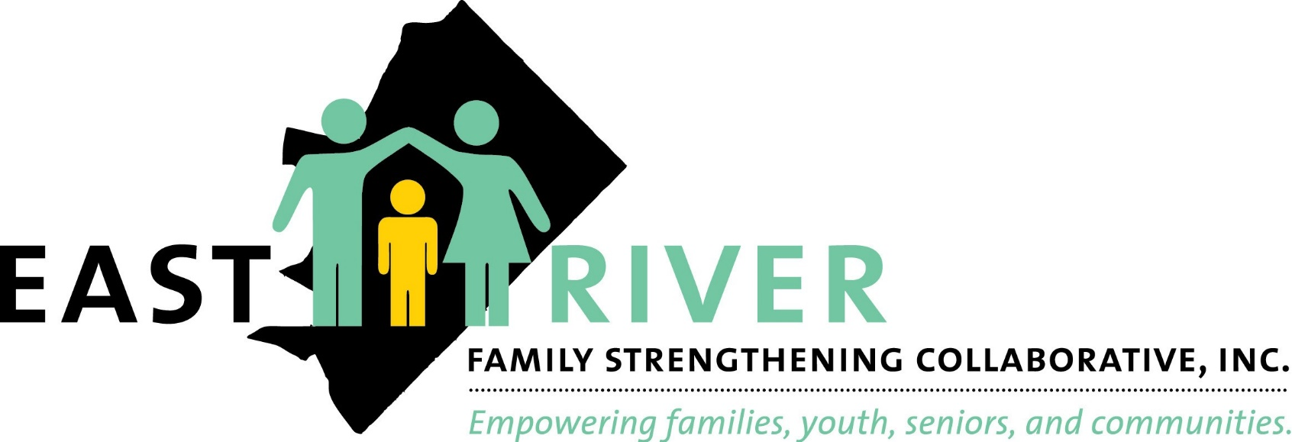
East River Family Strengthening Collaborative (ERFSC)

FY19 - Year in Review

"Share Our Passion.
Share Our Love"

Mae H. Best, LICSW Executive Director

3917 Minnesota Avenue, NE Washington, D.C. 20019 www.erfsc.org
(202) 397-7300

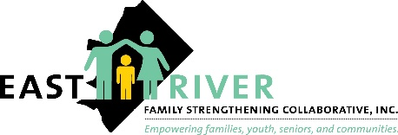
Snap-shot of East River Family Strengthening Collaborative (ERFSC)

As a hybrid agency, ERFSC offers direct services while simultaneously serving as a community hub. Through the support of local District of Columbia and federally funded grants and initiatives ERFSC has been fortunate enough to leverage its experience and grassroots base advocacy to more purposely serve and engage the community. These programs and services allow residents of Ward 7 and families to engage with one another in a unique way, shifting the focus from programming to actual family and/or community need. ERFSC’s Programs include case management, referrals and linkages, network and coordination of community-based services. ERFSC manages over nine contracts and grants providing services and supports to one of the District’s neediest populations in Ward 7. The supports include management of four senior services grants, managing truancy and attendance at 13 elementary and middle schools, overseeing youth linked to the DYRS, assisting families who are at risk of losing their TANF assistance, and working to support families who are homeless in finding housing and supporting families at risk of losing their children to the child welfare system.

In addition, ERFSC subcontracts to small community-based agencies in Ward 7, helping them to develop their own capacity to provide services to residents. In fiscal year 2019, ERFSC continued its work in adopting Protective Factors in its practice to promote the well-being of all of its program participants served in the agency. These are indicators or attributes in individuals, families, communities or the larger society that mitigate or eliminate risk in families and communities, thereby increasing the health and welfare of children and families. They help parents to find resources, supports, or coping strategies that allow them to parent effectively, even during periods of stress. Continued staff development opportunities on the framework of Protective Factors on parental resilience, social connections, concrete supports for parents, social and emotional competence of children and knowledge of parenting and of child and youth development will become entrenched in our work and practice in order to best serve and meet the needs of our residents.

The core of ERFSC is the dedicated staff made up of 91 Full-time and 23 Part-time staff who delivers and/or coordinates a range of services to the Ward 7 and 8 communities.

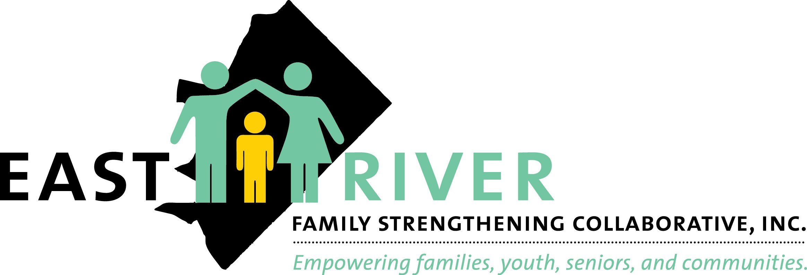
Case Management - A Core ERFSC Service
Case Management is a core service that runs across most programs offered at ERFSC. Case Management is the coordination and delivery of formal and informal services, activities and supports designed to optimize the well-being of children, youth, families and seniors residing in Wards 7 and 8.
ERFSC utilizes the 6 stages of case management model: Engagement, Assessment, Intervention, Monitoring and Coordination, and Termination (Discharge). In FY19, ERFSC served a diverse population of residents from Wards 7 and 8 ranging in age and household composition to include: children (0-16 years old), young adults (17-25 years old), single or two-parent heads of household (26-59 years old), and seniors (60 years old and over). Additionally, the majority if residents from Wards 7 and 8 have on annual a zero to low income ratio which creates economic instabilities that can be correlated to higher risk factors leading to the increase need for case management services.

Total Case Management Recipients 1,199

During FY19, Families, Youth and Seniors residing in Wards 7 and 8 received one or more of the core services provided through ERFSC case management services.

ERFSC Core Services
Eligibility Benefits Educational Workshops Parenting/Parenting Supports Fatherhood Services

Whole Family Enrichment Burial Assistance
Home Delivered Meals

Emergency Flex Funds
Medical Health (Adult)
Food Furniture
Tutoring
Nutrition Counseling

Referral
Mental Health (Adult) Employment/Employment Supports
Information

Child Care Assistance
Pest Control
Mental Health (Child)
Financial Literacy

Children's Education
Housing/Housing Supports Rental Assistance
Medical Health (Child)

Mentoring
Clothing Transportation Assistance
Youth Recreational Activities

Homemaker Services Utility Assistance Heavy House Cleaning
Caregiver Education

Comprehensive Assessment

CFSA Funded
Programs

Case Management Referrals

199
New families referred to
ERFSC for Case Management Services
96%

4%
192 - New Referrals Linked to services under 30 days
8 - New Referrals

(42) - FY-18 Rollovers
241 Families served

72%
Families referred to ERFSC and dismissed in FY19, successfully received services

Case Management Service Outcomes
Linked to services over 30 days

63%
Families referred to ERFSC and dismissed in FY19, were dismissed within the recommended length of stay

Families referred to ERFSC for housing assistance/housing supports
44

Housing

of the families requesting housing assistance/housing supports were successfully served via housing placements - 48% or housing supports - 43%
91%

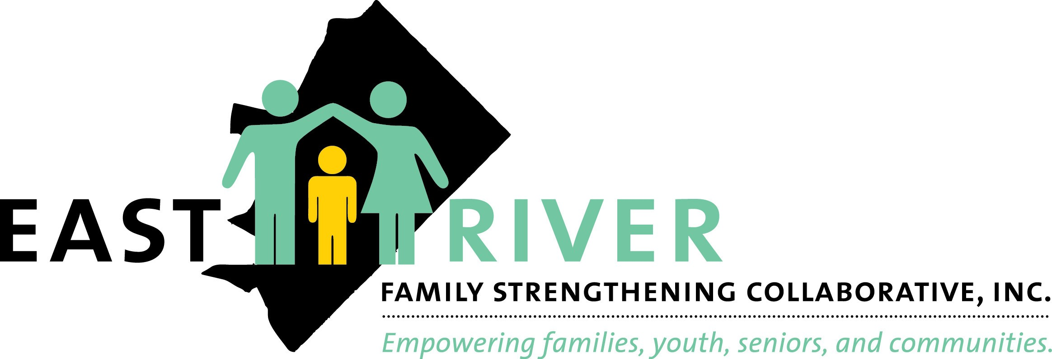

ERFSC successfully served 285 households referred through CFSA for case management and housing services

Non-CFSA Funded
Programs

Show Up,

495

2018-2019, ERFSC
student referrals from elementary schools in Ward 7
399

Stand Out (SUSO)
Truancy
Elementary Schools
87%
In-seat Attendance Rate
Completed Engagement Contacts by ERFSC
72%

Of the students were re-referrals during
15%

2018-2019 - eligible
students

2018-2019, ERFSC
166
student referrals from middle schools in Ward
7

Show Up, Stand Out (SUSO)
2018-2019 school year

84%
In-seat Attendance Rate
Completed Engagement

2018-2019 - eligible students
159

Truancy
Middle Schools
70%
Contacts by ERFSC
Of the students were
15%

Out of 534 eligible student referrals from elementary and middle schools 24 families were opened for Case Management Supports. The remaining 510 students received truancy supports for the reduction of truancy.

Family
re-referrals during 2018-2019 school year

During FY19, FRSP

62/100%
Families served in the FRSP sustained housing in FY19

Rehousing Stabilization Program (FRSP) Case Management & Supportive Housing Services

FRSP - 2019 Family Income at Start and Exit
families served
68
families, 117
children

35%

29%
33 families had other income sources at start

8 families had other income sources at exit
Families had earned income at the start

Families had earned income at exit
14
6

Effective Black Parenting

Participants enrolled in the Effective Black Parenting Curriculum
72
of participants
Successfully completed one of the parenting curricula
59%

87 - Successfully Completed 37 - Unresponsive
02 - Refused Services 21 - Withdrew
Chicago Parenting

Participants enrolled in the Chicago Parenting Curriculum
75

Nurturing Parents

Participants attended and successfully completed one of eighteen Nurturing Parents sessions
41
26

Safe Sleep

Participants enrolled in the
Safe Sleep program and received Safe Sleep equipment. 100% of participants shows a change in learning acquisition evidence via Pretests and Post-tests

Parent Cafes'
69
Families attended one of five Parent Cafes' sessions

Active Parenting of Teens

Participants attended the sessions
15

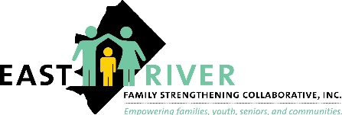

Services
(n=238)

Across the ERFSC parent education programs 238 families were successfully served

Supportive Services
(n= 228)

Financial Literacy (91% Learning Increase)
Participants completed financial literacy demonstrated increased knowledge acquisition evidenced via Pretests and Post-tests
100

Whole Family Enrichment- Movie Night

Participants attended Movie Nights sponsored by ERFSC
18

Pre-Mother's Day Celebration
49
Participants attended the two day Pre-Mother's Day Celebration sponsored by ERFSC

Winter Wonderland
Families and 250 children participated in the Winter Wonderland event sponsored by ERFSC. 25 parents were enrolled in one or more parenting programs
50

Benning Terrace Workshops
BT
11
Participants attended weekly parenting support activities

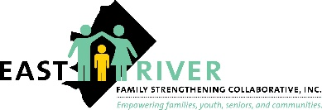

Across ERFSC parenting education supportive services 228 families were successfully served

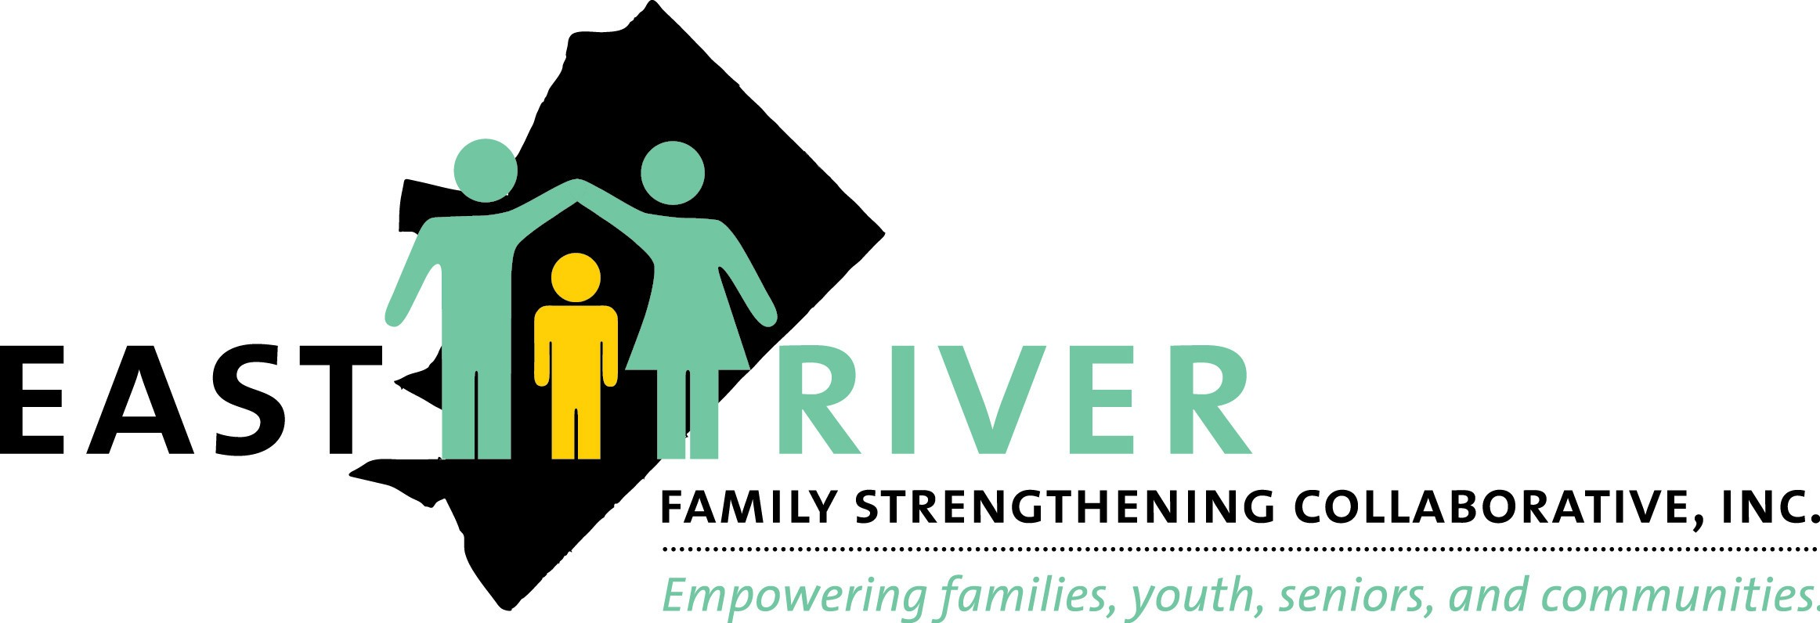
FLEX FUNDS
2019

CFSA Funded Flex Fund Expenditures

85,934.81
CFSA Family Involved & CPS Request (Entry Services)
23,242.19
31,675.62
19,805
3,780
2,250
882
4,300

Rental Assistance
Security Deposit
Homemaker Services
Pest Control

Utility Assistance
Burial Assistance
Furniture Assistance
Total Spent

Emergency Housing
25,393.85

19,336.47
6,059.38

Rental/Housing

Utilities
Total Spent

3,000

Non- CFSA Flex Funds Expenditures

2,000

1,000

0
November January February March April May June July August September

Total: $11,911.83

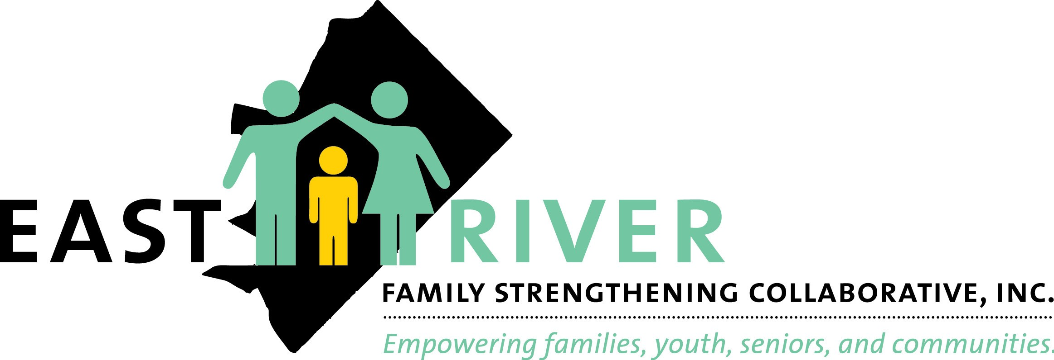
FY19
Senior Services Lead Agencies (Wards 7 and 8)

Ward 7 Ward 8

Case Management
Served 498 distinct seniors, providing 3,411.50 service units

Case Management
Served 342 distinct seniors, providing 1,788.50 service units

840 Seniors Served

Comprehensive Assessments
Served 207 distinct seniors, providing a total of 683.50 service units

Counseling Services

Comprehensive Assessments
Served 138 distinct seniors, providing a total of 426.50 service units

345 Seniors Served

Counseling Services

Served 1728 distinct seniors, providing a total of 8,268.75 service units

3226 Seniors Served
Served 1498 distinct seniors seniors, providing a total of 10,866.50 service units

Congregate Meals
Congregate Meals

Served 473 distinct seniors, providing a total of 23,935 service units

1023 Seniors Served
Served 550 distinct seniors, providing a total of 37,872 service units

Lead Agency Wards 7 and 8 successfully served a combined total of 5,434 distinct seniors in the above categories

Senior Services Lead Agencies (Wards 7 and 8)

Ward 7 Ward 8

Home Delivered Meals (Weekday)
Served 825 distinct seniors providing a total of 160,963 service units

Home Delivered Meals (Weekend)
Served 315 distinct seniors providing a total of 24,005 service units

Home Delivered Meals (Weekday)
Served 555 distinct seniors providing a total of 105,010 service units

1380 Seniors Served

Home Delivered Meals (Weekend)
Served 404 distinct seniors providing a total 27,960 service units

719 Seniors Served

Health Promotion

Served 491 distinct seniors providing a total of 24,153 service units

1021 Seniors Served
Health Promotion

Served 530 distinct seniors providing a total of 14,054.50 service units

Nutrition Counseling

Served 81 distinct seniors providing a total of 197.50 service units

374 Seniors Served
Nutrition Counseling

Served 293 distinct seniors providing 803.50 service units

Lead Agency in Wards 7 and 8 successfully served a combined total of 3,494 distinct seniors in the above categories

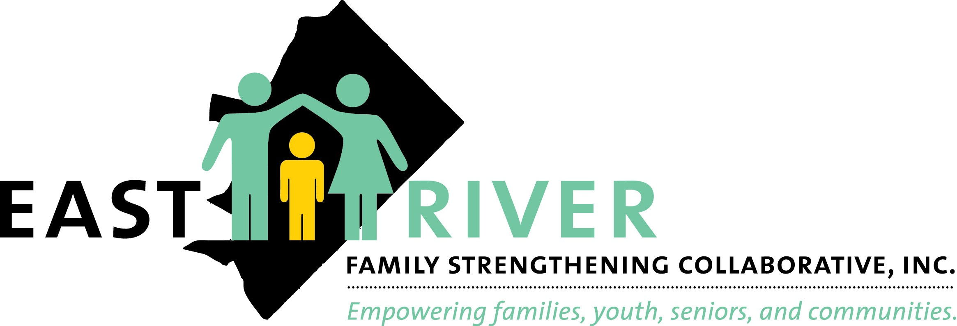
FY19
Washington Senior Wellness Center
(Ward 7 )

Objective 1: (Target
375)/Actual 742)

Preventive Health, Disease Management and fall prevention provided to 742 distinct seniors

Objective 2: (Target 75/Actual/114)
2a. Evidenced-Based, title III-D disease prevention and health promotion provided to 75 distinct seniors

(Target 10/Actual 40)
2b. Chronic disease management provided to 10 distinct seniors

Objective 3: (Target
400/Actual 6,107)
Recreational/socialization program, travel opportunities, educational outings to 400 distinct seniors

Objective 4: (Target
75/Actual 91)
Inter-generational programming for 75 distinct seniors and young people

Objective 5: Target Achieved

Develop a civic engagement program to encourage a high level of community involvement for 60 distinct seniors

Objective 6: New Member Enrollment (Target 75/Actual 105)

Structured outreach to inform and enroll new Ward 7 seniors

Accomplishments:
Implementation of new partnership with Global Youth Service Arts Project for inter-generational programming
Exceeded new membership enrollment by 40% Developed a partnership with LYFT Foundation resulting in the purchase of new equipment for the game room
Recognition of over 60 volunteers in the first annual volunteer recognition day

Community Engagement & Partnerships
2019

Youth Programming

Program Name | Program Goal | Target Audience | Amount Awarded
The Soccer Pros (Hip Hop) | Teaches youth the art of Hip Hop Dance | 13-17 year old | $10,000
The Soccer Pros (Robotics) | Introduces robotics | 11-13 year old | $10,000
The Green Scheme | Teaches youth the basics of farming | 6-12 year old | $8,000
The Thinking Cap | Teaches self-love, career goal planning and managing finances | 6-12 year old | $8,000
Day Break | Teaches youth basic life skills and how to care for their community | 5-13 year old | $3,000

Youth Programming

Behavioral Health Opioid Response Grant

Program Name | Program Goals | Target Audience | Amount Awarded
Rock the Block | 40 youth to complete Evidence-Based Curricula (Life Skills) and complete two environmental strategies | 12-24 year old | $100,000

Youth Programming Deputy Mayor's Office on
Education, Out of School Time,
Administered through United Way

Program Name | Program Goal | Target Audience | Amount Awarded
Safe Passages | Ensures student walking to and from school along the Minnesota Avenue corridor are safe through community watchers | 5-18 year old | $50,000

Senior Programming
Economic Development, New Communities

Program Name | Program Goal | Target Audience | Amount Awarded
New Communities Grant | Deliver health and wellness service to seniors | 55 years and older | $45,000

Community Engagement & Partnerships

Outreach Outcomes Types (n=155 events)
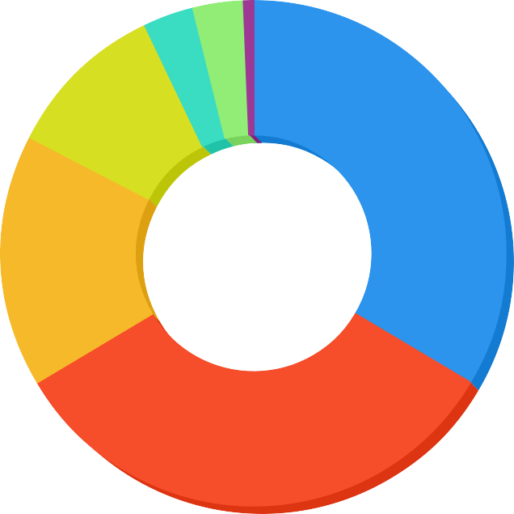

General Special Event Other Workshop Training Child Abuse/Neglect Safe Sleep Fundraising

Summary
Numerical
Outreach

Participants Reached (n= 16,003)

Materials Distributed (n=9,197)

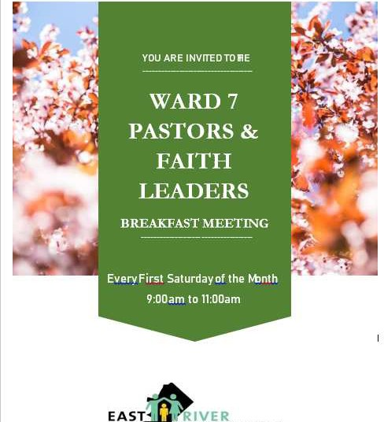
Leaders'Breakfast
Faith
Meeting

In collaboration with the Metropolitan Police Department – Sixth District, ERFSC was the lead in organizing monthly Ward 7 Faith Leaders’ Breakfast meetings. The focus of these meetings were to engage local clergy in the discussion and planning for reducing violence and increasing safety in Ward 7 communities. The first session was conducted in March 2019, and every subsequent month the Ward 7 Faith Leaders Breakfast has been held with various clergy within and outside of the Ward 7 community with vibrant and thoughtful ideas being presented through training and other forms of information. These meetings are important to the overall success in violence reduction in Ward 7 and will continue through fiscal year 2020. The goal for FY20 is to move from planning to implementation of actions with a collective community approach in addressing violence and violence reduction in Ward 7.

Major Stakeholders
2019

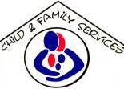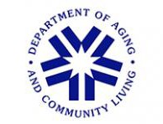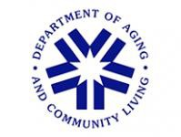
Click to edit this text

(CFSA)
$3,360,919.81
(DACL)
Ward 7 Lead Agency) 1,723,353.00
(DACL)
Ward 8 Lead Agency
$1,425,760.00

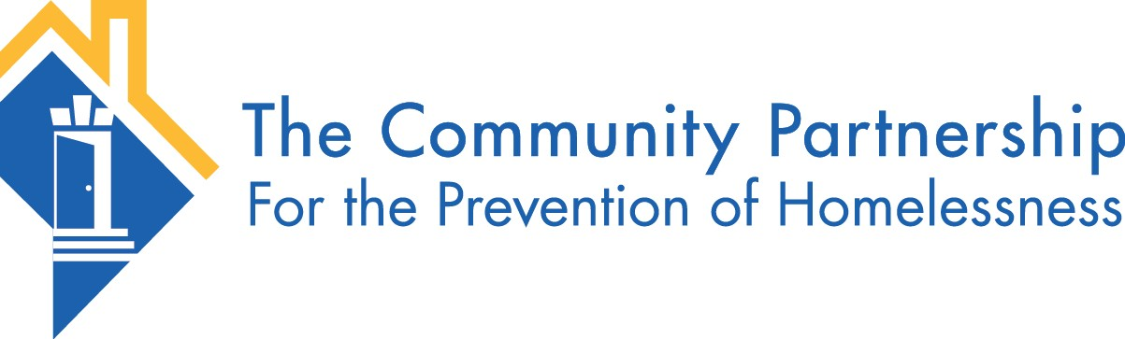

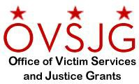
Office of Victim Services and Justice Grants
$622,161.00

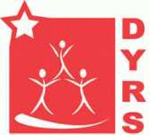
(DYRS/Progressive Life)
$472,513.00
(TCP)
$396,200.00

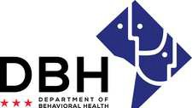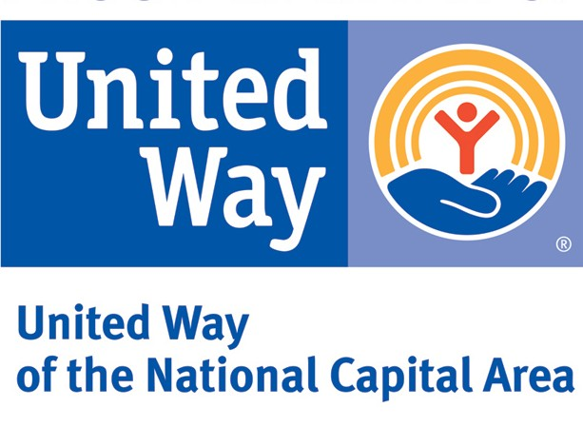

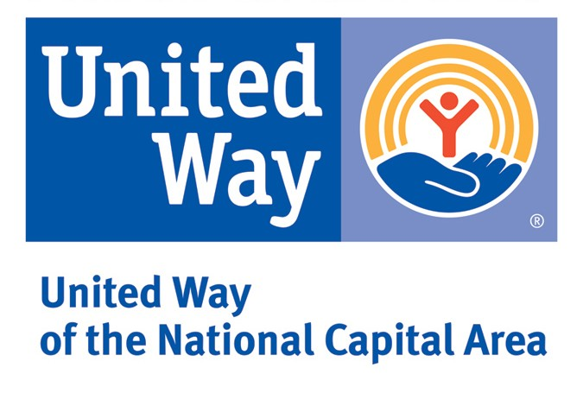
United Way Out of School Time
$100,000
Department of Behavioral Health (DBH)
$100,000
United Way Safe Passages
$50,000

Other FY19 - Funding Streams Office of the Deputy Mayor for Planning & Economic
Development
$40,000.00
Community Foundation
$5,000.00

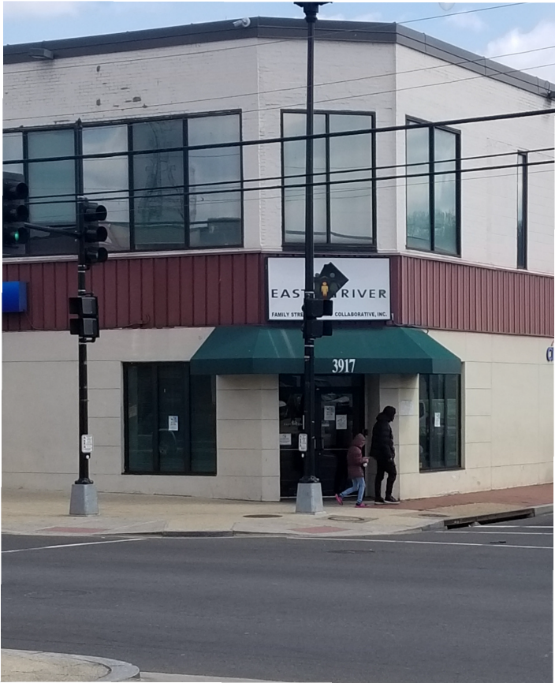
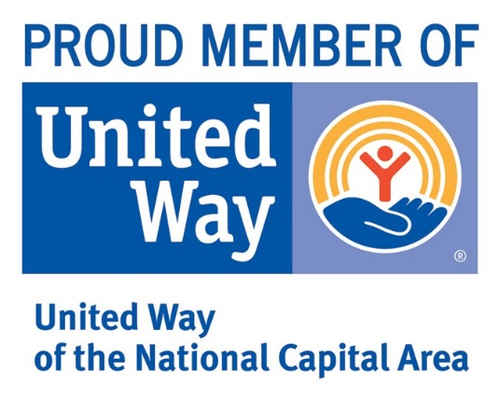
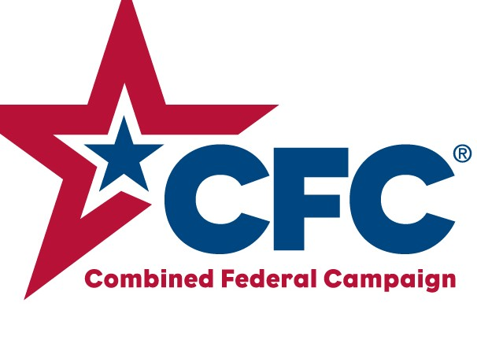
East River Family Strengthening Collaborative, Inc.

3917 Minnesota Avenue, NE Washington D.C. 20019

Connect with us...

(202) 397-7300 EastRiverFamily ERFSCWard7 @erfsc

9047
12771

